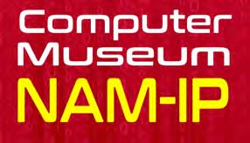
Namur, October 27th, 2017
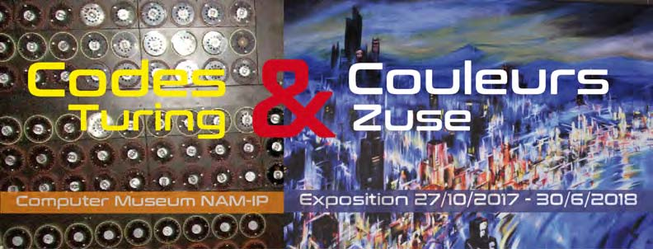

Exhibition
One year after it’s opening, the NAM-IP computer museum presents a temporary exhibition called “Codes & Couleurs – Turing & Zuse”.
A museum where the permanent exhibition is called “To the sources of the digital world, machines that count” also has to pay tribute to those who were at the origin of our digital culture.
Alan Turing is considered one of the first theoreticians of computer science and artificial intelligence, but is commonly remembered for his work leading to the decryption of German military codes, that helped to
significantly shorten the second world war (1940-1945).
Far less known is the first “computer” (a calculating device using binary numbers and whose program was
stored in the memory of an originally electromechanical, later electronic apparatus) who was developed by a German engineer Konrad Zuse (1910-1955) between 1938 and 1945. His work was the foundation of the German computer industry by Siemens from 1967 onwards. In order to get a better knowlegde of this less well known person (due to the period in which his major work was done), the exhibition brings a small selection of oil paintings he mainly made during the later part of his life, while still developing his electronic machines.
This exhibition at the NAM-IP computer museum was made possible by a loan of the exhibition “Alan Turing. Du langage formel aux formes vivantes” organised by Pierre Mounier-Kuhn at the Pierre and Marie Curie University in Paris, and by a donation made by the Kurt Pauli Foundation (Bonn) of reproductions of paintings by Konrad Zuse.
Practical information
Exhibition: from 31 October 2017 until 30 June 2018
- Until 31 March 2018: from Monday until Friday : 10 am - 5 pm
- From 1 april 2018 : from Tuesday until Saturday : 10 am - 5 pm and
First Sunday of the month : 2 pm - 5 pm
Computer Museum NAM-IP
Rue Henri Blès 192A – B5000 Namur
Tel: +32 81 34 64 99
Direction@nam-ip.be

