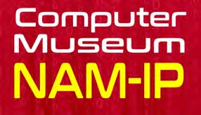
Namur 25 october 2018
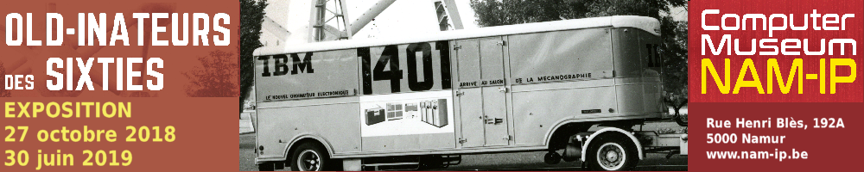

Exhibition
To commemorate the second anniversary of our opening, the NAM-IP computer museum holds a temporary exhibition called
Old-Inateurs des sixties
The NAM-IP computer museum proposes a retrospective on the large computer systems typical for the years 1960-1970.The 1958 World Trade exhibition in Brussels may be considered to be the launch of the deployment on a large scale of IT in the Belgian public and private sector.
This exhibition offers a unique opportunity to (re)discover these imposing machines, now totally absent in today’s IT landscape.
A model, representing the machine room of the RTT (predecessor of Belgacom-Proximus) during the years 1962 – 1974 is the focal point of the exhibition. With this model one can imagine and visualise how IT was during this pioneering period. The exhibition will also highlight artefacts from the sixties, owned by the Fund Pioneering IT in Belgium, that have been entrusted to the museum by the King Baudouin Foundation.
This exhibition will also be the start of a biennial cycle that will take the visitor from the antique machines to the quantum-era machines, covering many generations of computers.
Practical
Exhibition open from 27 October 2018 until 30 June 2019
- until 31 March 2019: Monday to Friday: 10am – 5 pm
- from 1 April 2019: Tuesday to Saturday: 10 am – 5 pm and
- the first Sunday of the month: 2 pm – 5 pm
At the Computer Museum NAM-IP
Rue Henri Blès 192A – B5000 Namur
Tél: +32 81 34 64 99
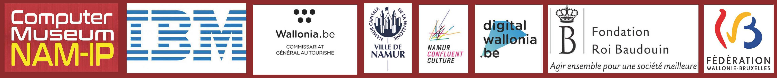
Direction@nam-ip.be

