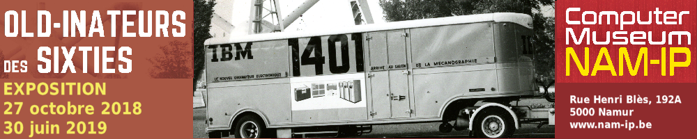

Exhibition
Old-Inateurs des sixties

Many larger Belgian companies and establishments ordered their first computer in the sixties. The 1958 Brussels World Fair was the trigger for this phenomenon in our country.

The arrival of mini and micro computers, and office computers somewhat later, was the beginning of the end for most of these machines who required enormous spaces for deployment and storage.

This temporary exhibition presents the visitor a unique opportunity to discover or rediscover these large systems. Mainframes from Bull, IBM and Unisys, already well represented in our museum, make up the core of this project.

The temporary exhibition will allow visitors to realise the overwhelming dimensions of the electronic data processing systems of the sixties. It will also give a good understanding
of the significant progress computers made during the 1960-70 period and the revolution in this domain that took place in this time frame.

Our first anniversary was the occasion to organise a first temporary exhibition from October 2017 until June 2018. “Old-inateurs des sixties” is the first in a biennial cycle,
“De l’informatique antique à l’informatique quantique en Belgique”, highlighting the many periods in the history of IT technology and emphasising on the role of the human in these innovations.
The 2017-2018 exhibition, featuring two IT pioneers, Alan Turing and Korad Zuse attracted many visitors.

Practical
The exhibition is open to the public from 27 October 2018 until 30 June 2019.
- Until end of March 2019: Monday to Friday from 10 am to 5 pm.
- From April until June: Tuesday to Saturday from 10 am to 5 pm,
and also on the first Sunday of the month from 2 pm to 5 pm.
- Outside these hours on request only.

Computer Museum NAM-IP
Rue Henri Blès 192A – B5000 Namur
Tél: +32 81 34 64 99
Direction@nam-ip.be

